**Currency Converter**

The Currency Converter is a Python application that allows users to convert between different currencies using real-time exchange rates. It features a simple graphical user interface (GUI) created with tkinter and relies on the requests library to fetch the exchange rate data from the ExchangeRate-API.

* **Key Features:**
* Convert between different currencies.
* Real-time exchange rate updates.
* Error handling for invalid inputs and network issues.
* **Requirements:**
* Python 3.x
* tkinter library
* requests library
* **Usage:**

1. Enter the currency code to convert from.
2. Enter the currency code to convert to.
3. Enter the amount to convert.
4. Click the "Convert" button to see the converted amount.

* **EXAMPLE OUTPUT:**

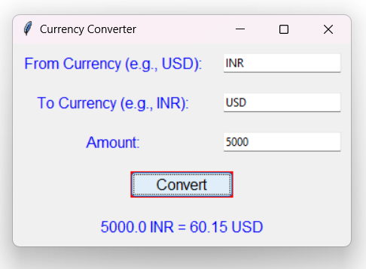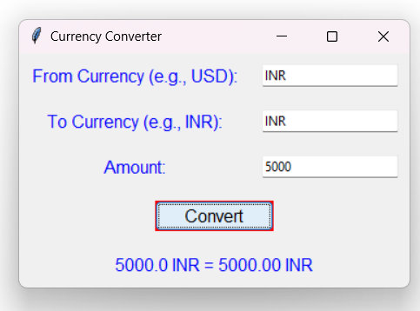

* Here is a list of currency codes in ISO 4217 format that you can use in your Currency Converter project:

"USD", "EUR", "GBP", "INR", "AUD", "CAD", "SGD", "CHF", "MYR", "JPY", "CNY",

"AED", "AFN", "ALL", "AMD", "ANG", "AOA", "ARS", "AWG", "AZN", "BAM", "BBD",

"BDT", "BGN", "BHD", "BIF", "BMD", "BND", "BOB", "BRL", "BSD", "BTN", "BWP",

"BYN", "BZD", "CDF", "CLP", "COP", "CRC", "CUP", "CVE", "CZK", "DJF", "DKK",

"DOP", "DZD", "EGP", "ERN", "ETB", "FJD", "FKP", "FOK", "GEL", "GGP", "GHS",

"GIP", "GMD", "GNF", "GTQ", "GYD", "HKD", "HNL", "HRK", "HTG", "HUF", "IDR",

"ILS", "IMP", "IQD", "IRR", "ISK", "JEP", "JMD", "JOD", "KES", "KGS", "KHR",

"KID", "KMF", "KRW", "KWD", "KYD", "KZT", "LAK", "LBP", "LKR", "LRD", "LSL",

"LYD", "MAD", "MDL", "MGA", "MKD", "MMK", "MNT", "MOP", "MRU", "MUR", "MVR",

"MWK", "MXN", "MZN", "NAD", "NGN", "NIO", "NOK", "NPR", "NZD", "OMR", "PAB",

"PEN", "PGK", "PHP", "PKR", "PLN", "PYG", "QAR", "RON", "RSD", "RUB", "RWF",

"SAR", "SBD", "SCR", "SDG", "SEK", "SGD", "SHP", "SLE", "SLL", "SOS", "SRD",

"SSP", "STN", "SYP", "SZL", "THB", "TJS", "TMT", "TND", "TOP", "TRY", "TTD",

"TVD", "TWD", "TZS", "UAH", "UGX", "UYU", "UZS", "VES", "VND", "VUV", "WST",

"XAF", "XCD", "XDR", "XOF", "XPF", "YER", "ZAR", "ZMW", "ZWL"